📌 Weekly Report

📆 **Week:** 2025/02/25 - 2025/02/27  
👤 **Internship Position:** Equity Research Intern  
🏢 **Company:** Asian Technology Advisor  
👨‍💼 **Supervisor:** Cecilia, Andy

1. **Tasks Completed**

[✔] Onboarding, PC Setup, discussion on the ***Statistical Analysis on Beat/Miss*** with Andi

[✔] Learning to use Bloomberg terminal, Bloomberg training course

[✔] Attempts with Bloomberg python API/ Excel add-in formula

[✔] Building the analysis framework, data acquisition, data preprocessing (≈50% complete)

[✔] Some preliminary beat/miss analysis and outcomes (Figure + Metrics)

[✔] CAAM monthly report analysis and data summarization (for supporting Sen)

1. **Key Achievements**

***Background***:

The building the data pipeline for acquisition is time consuming. Therefore, I manually selected 5 equities and 1 index from USA, semiconductor sector and built the analysis framework using the past 10 years historical data. After discussion with Andi and aligning with Cecilia, I decided to do some preliminary analysis on ① the fluctuation of market/equity ② the change of “exceed return” (stock return – index return).

***Methodology***:

It is divided into 4 categories: “Beat up”, “Best down”, “Miss up”, “Miss down”. “Beat up” is defined as when there’s a company beat after finance report release, the stock price increases in the second trading day. The stock price/index price within a certain period after each beat/miss is extracted and the statistical indicators are calculated with different equities. The “avg exceed return” of “beat up” is calculated and visualized categorized by equities.

***Framework***:

Changeable parameters are

1. beat threshold/ miss threshold (3% 5%? 10%?)

2. the observation window size after the beat/miss

3. Equities, Index selection (Once fully automated, it can simultaneously process large amounts of stock data from different equities)

***Phase Outcomes:***

I analyzed statistical indictors for the 4 situations for 5 companies:

["NVDA US Equity", "AVGO US Equity", "TXN US Equity", "QCOM US Equity", "AMD US Equity"]

Index: Semiconductor Manufacturing Industry (SOX Index)

1. Based on the analysis result, equities tend to show higher beat and lower miss.

Therefore, setting beat_threshold = 0.05, miss_threshold = 0.02, observation_window_size=50 trading days:

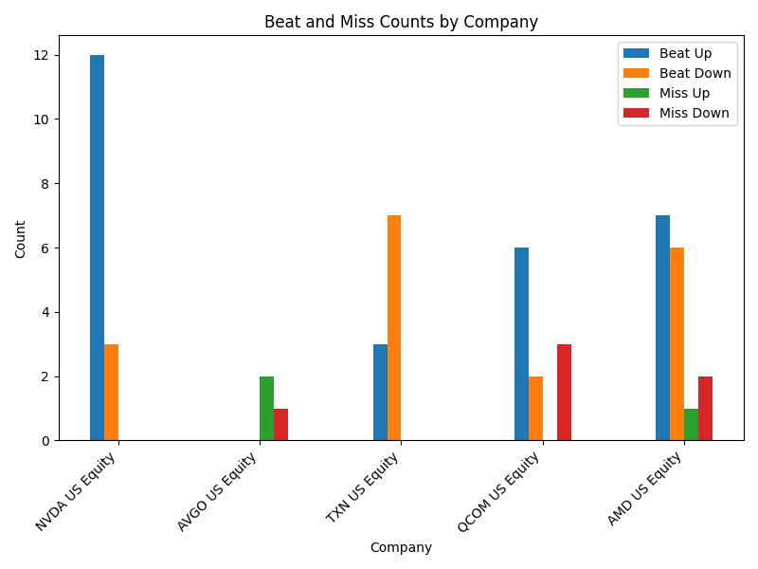

There seems to be significant variance between different equities. With more equities involved can result in more objective distributions.

1. Due to the working hours, I analyzed the “***excess return” (stock return – index return***) only for “***Beat up***”. 50 days result is as shown in the figure:

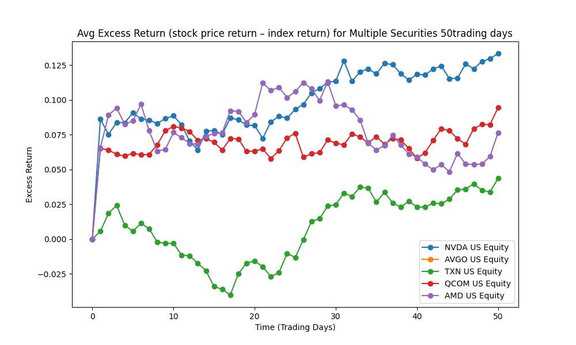

Equities are receiving persistence increase in excess return except TXN. AVGO has no beat over 5% so there’s no data in this figure.

Adjusting the parameter to 3% of beat threshold and 2% of miss threshold, the result is as shown here:

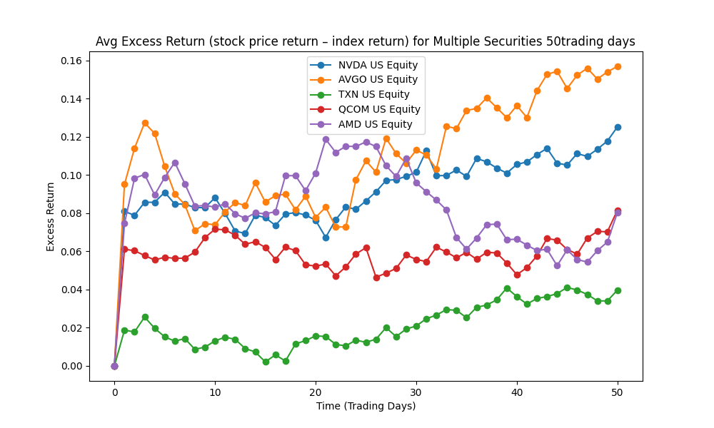

1. The AVG Beta for “beat up” is calculated for 50 days period as shown below, further analysis will be raised regarding to the fluctuation.

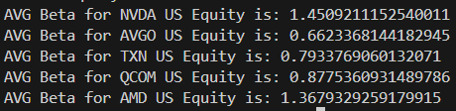

1. Challenges

Challenge 1: Not familiar with Bloomberg terminals, API, excel formula

Solution: Become proficient through repeated use

Challenge 2: Not familiar with some stock market terms/concepts

Solution: Learn and look up by myself, consulting with Andi for insights.

Challenge 3: Building the data pipeline is time consuming

Solution: In order to analyze the whole sector or from macro perspective, the automated data pipeline is needed. At this stage, concentration will be on the core analysis. The pipeline will be setup step by step. And more analysis methods will be also added to the framework.

1. Next Week’s Plan

* Introducing more analysis methods and indicators to the analysis framework by aligning with Cecilia and consulting with Andi.
* Refining the data pipeline (1. Data acquisition 2. automation)
* Support other Analysts (Gaming device data summarization to support Sen)